Output for inventory_self_rag.py
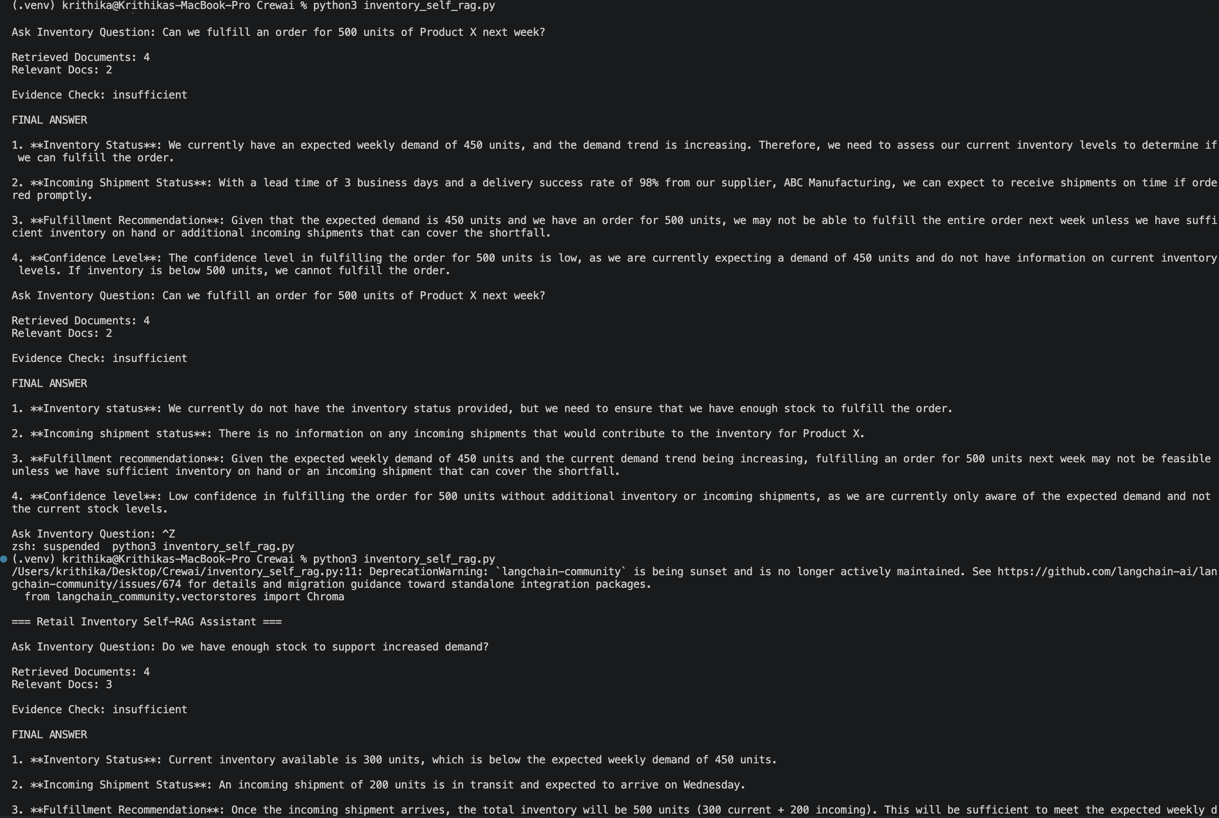
Exact scenario captured with exit :
